COMPUTER ORGANIZATION AND ASSEMBLY LANGUAGE

TOPIC:
BIT MANIPULATION

NAME:
MUHAMMAD TALHA
SECTION:
4/A
ROLL NUMBER:
241890

INSTRUCTOR:
MS. ROMANA MAROOF

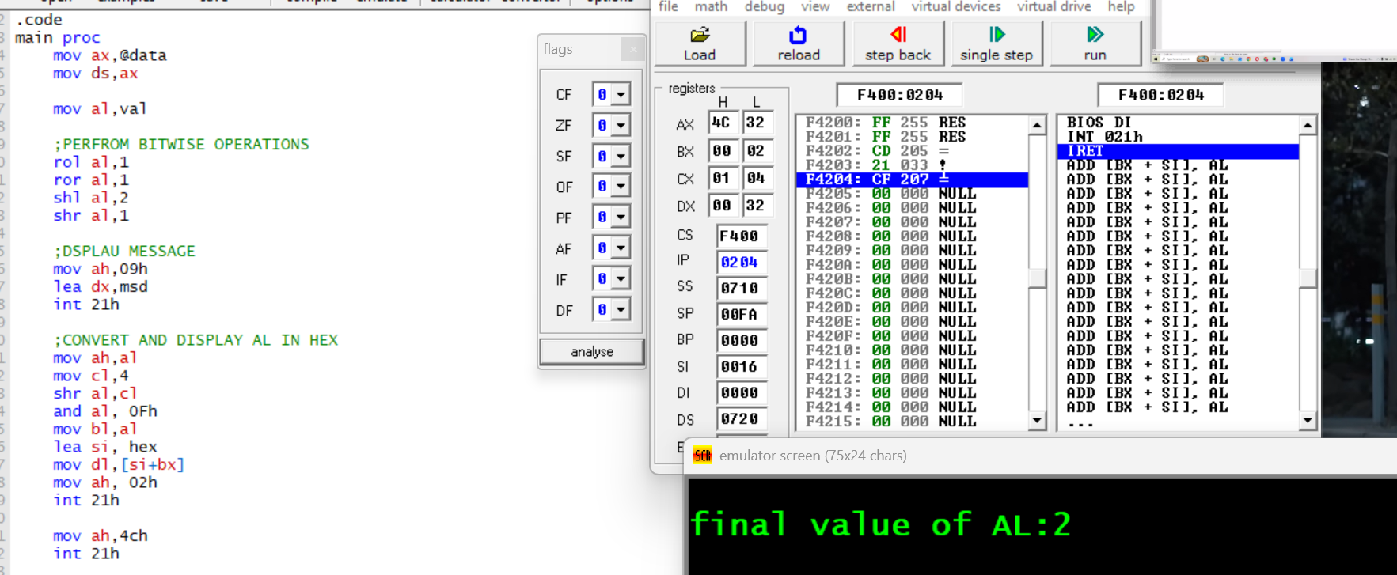
LAB EXAMPLE #3

Command: rol al,1 Results:67
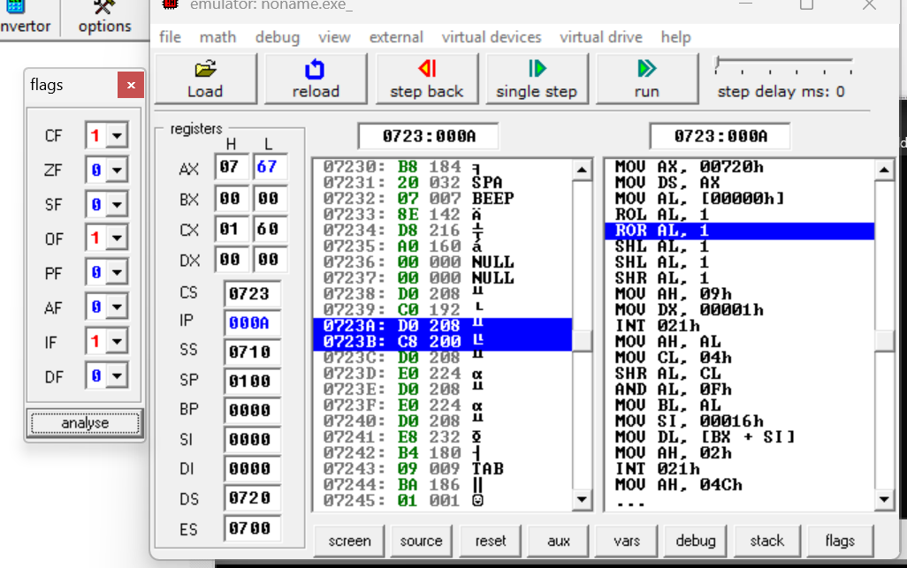

Command: ror al,1 Results: B3h
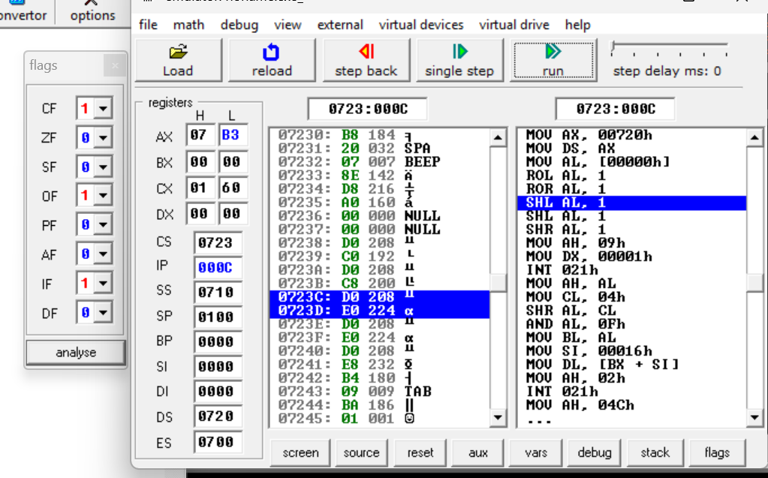
Command: shl al,2 Results: CCh
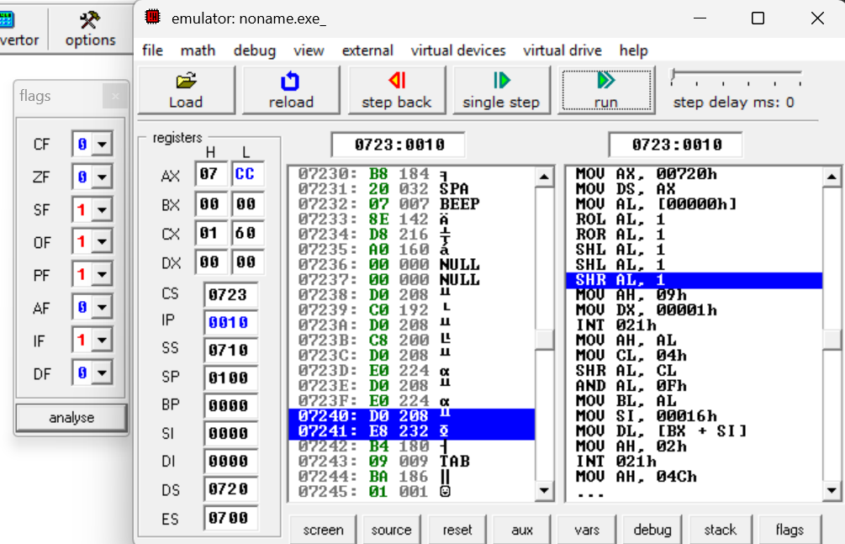

Command: shr al,1 Results: 66h
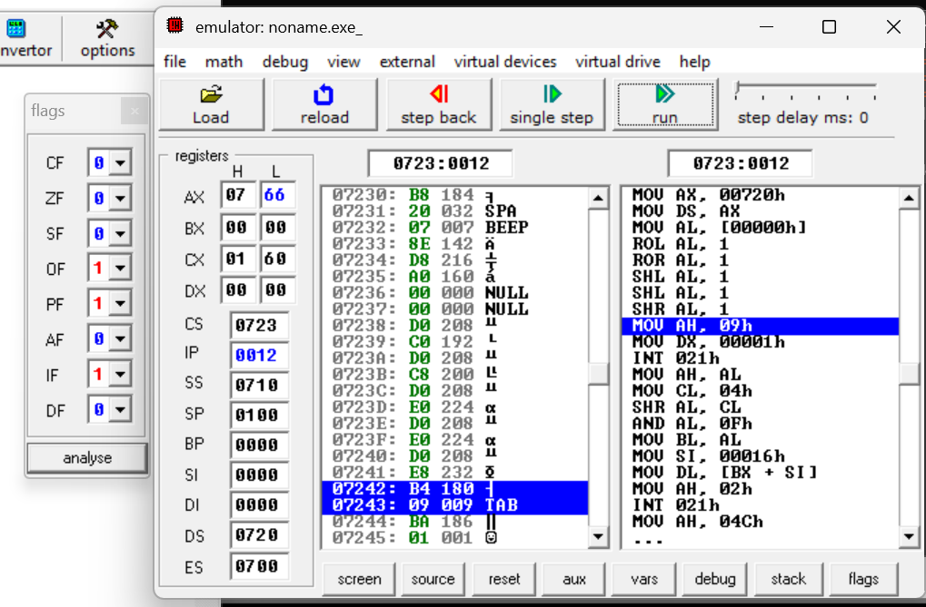
Command: shr al,cl Results: 02h
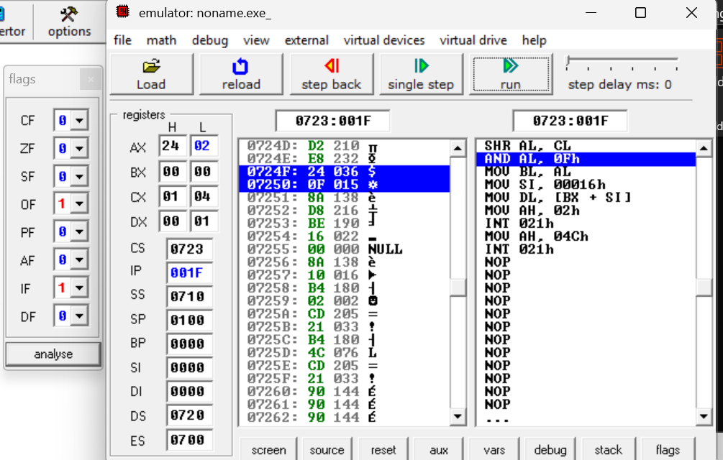

Command: and al, 0Fh Results: 02h
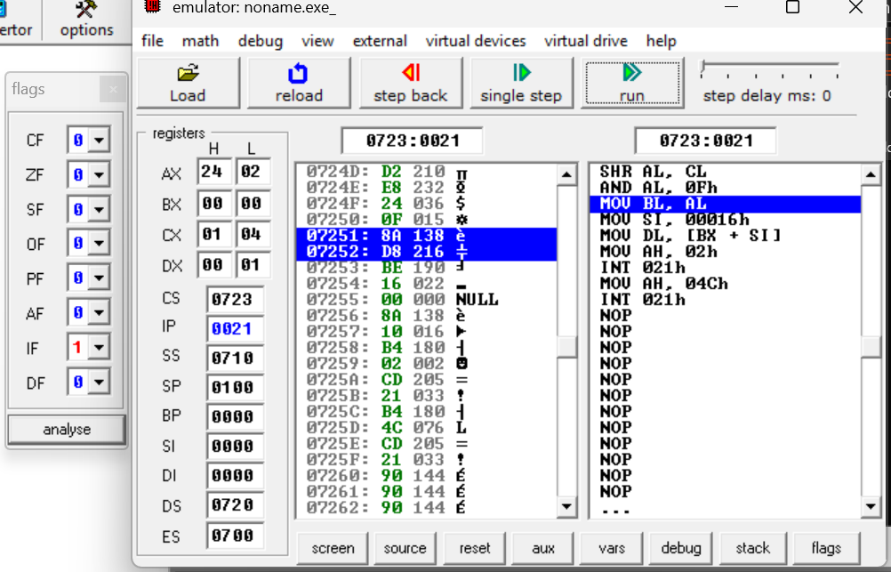
Final Answer:
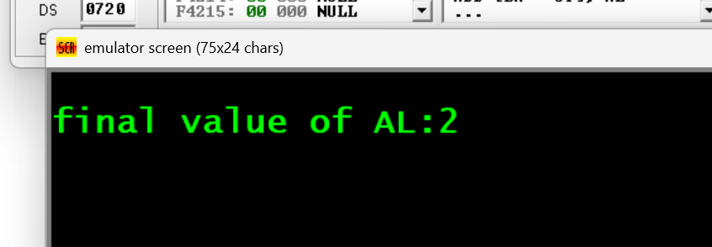

TASK#1
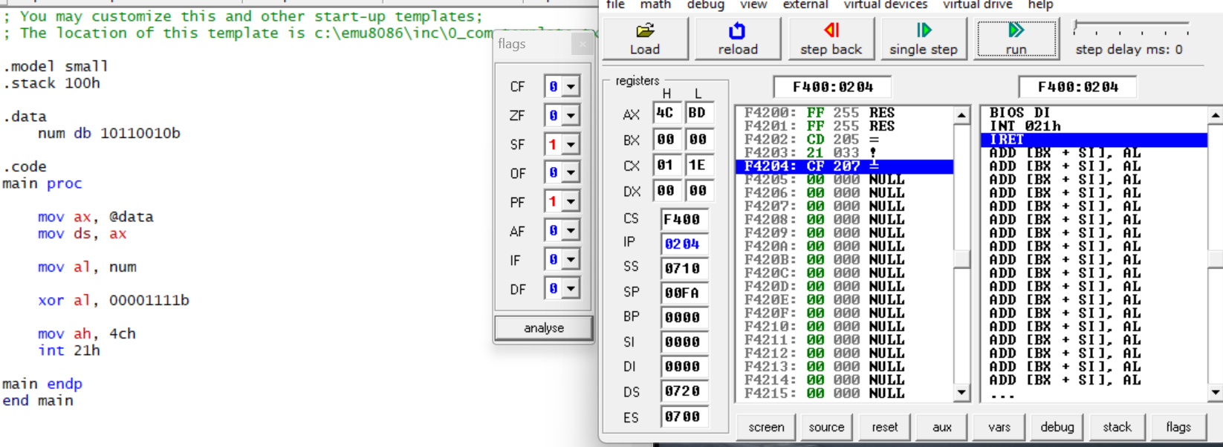
Toggle only the lower 4 bits of a byte using XOR and masks.

COMMAND: xor al, 00001111b RESULTS:BDh
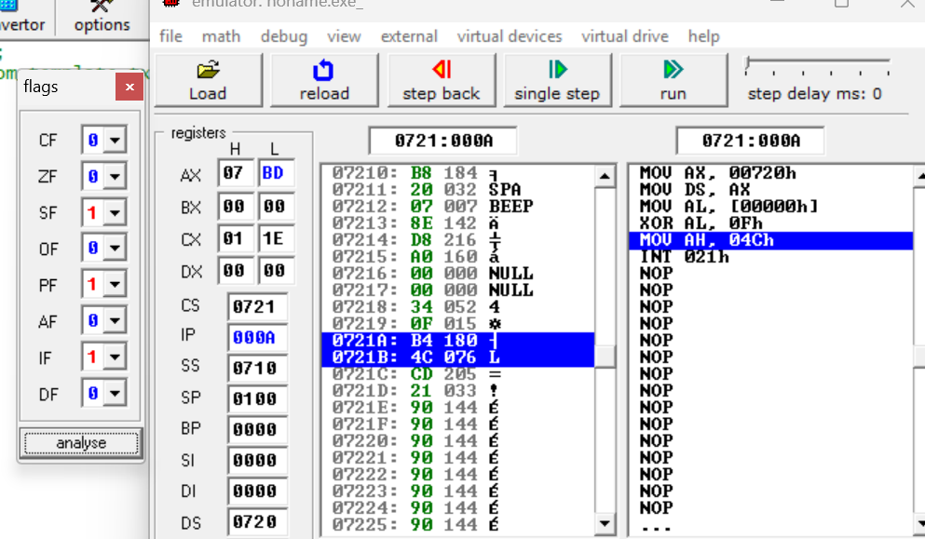

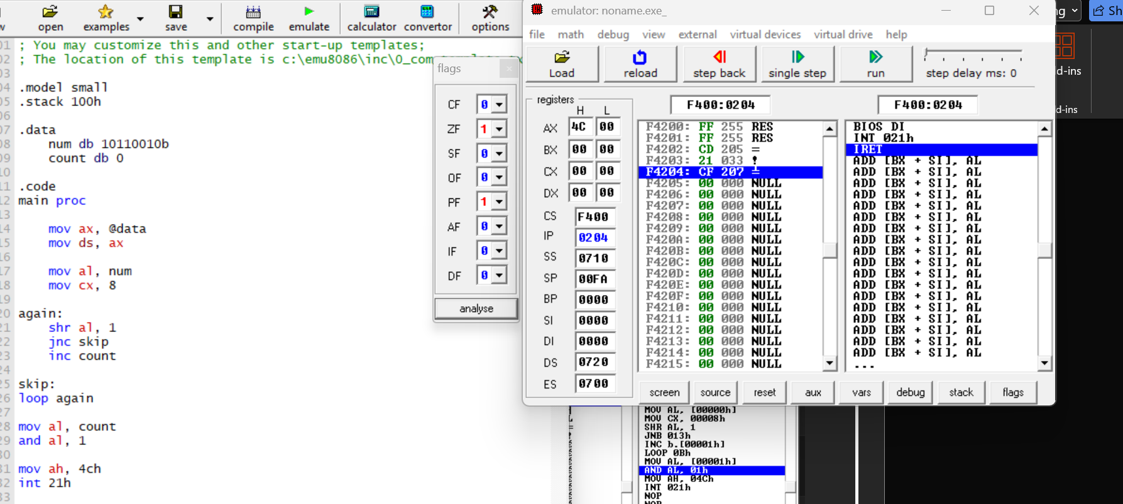
TASK #2

EXPLAINATION:
mov al, num load the byte
shr al, 1 check each bit using carry flag
jnc skip if bit is 0, ignore
inc bl count number of 1s
after loop:
and bl, 1
0 => even parity
1 => odd parity

COMMAND: MOV AL, COUNT RESULT: AL=4
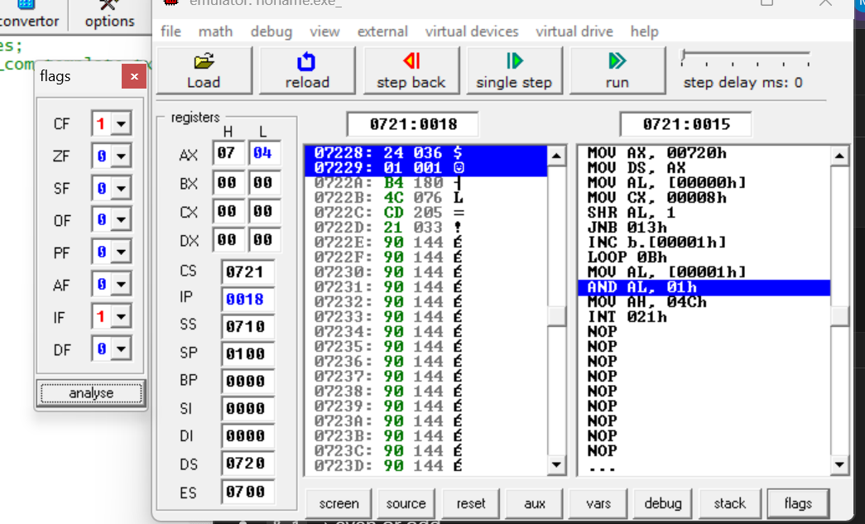

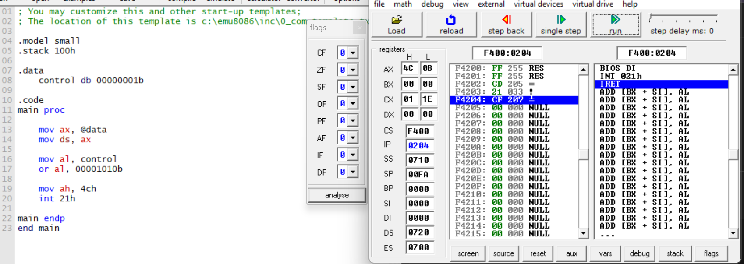
LAB TASK#3

EXPLAINATION:
control holds current light states
or al, 00001010b:
- turns ON bit 1 and bit 3
- keeps other bits unchanged
before: 00000001
mask: 00001010
after: 00001011

